***Department of Computer Engineering***

**Academic Term: January - May 2023**

Class**: *B.E (Computer) Semester VIII*** Division***: A***

Subject Name**: *Distributed Systems CSC 801***

**Assignment II**

## Case Study: Distributed system Design

***Examples: Twitter, Google Search Engine, Facebook, YouTube, Uber, etc.***

|  |  |
| --- | --- |
| Roll No: | **9427** |
| Name of the Student: | **Atharva Pawar** |
| Date of Submission | ***12/03/2024*** |

Evaluation:

|  |  |  |
| --- | --- | --- |
| **Sr. No** | **Rubric** | **Grade** |
| **1** | **Timeliness** | **/2** |
| **2** | **Level of Content [clearly mention the source of your literature]** | **/4** |
| **3** | **Knowledge/Understanding about Distributed Systems** | **/4** |

**Signature of the Teacher :**

**CASE STUDY TOPIC :** UNVEILING TWITTER'S DISTRIBUTED SYSTEM ARCHITECTURE

# INTRODUCTION

In the realm of social media, Twitter stands as a ubiquitous platform, connecting millions of users worldwide in real-time conversations. Behind its seemingly simple interface lies a sophisticated distributed system architecture, meticulously crafted to handle massive volumes of data, ensure seamless user interactions, and maintain high availability. This case study delves into the intricacies of Twitter's distributed system, shedding light on the key components, design principles, and scalability measures that underpin its operation.

Twitter's journey from a humble microblogging platform to a global social media giant has been marked by numerous technical challenges. As its user base expanded exponentially and the volume of tweets soared, the need for a robust infrastructure capable of supporting this growth became paramount. In response, Twitter engineered a distributed system architecture that harnesses the power of distributed computing, fault tolerance mechanisms, and real-time processing to deliver a seamless user experience.

Throughout this case study, we will explore the various facets of Twitter's distributed system architecture, starting from the identification of key components such as the user interface, backend services, data storage, messaging system, and content delivery network (CDN). We will then delve into the design principles that govern each component, emphasizing scalability, fault tolerance, real-time processing, and efficient data management.

Furthermore, we will examine the implementation of scalability measures such as horizontal scaling, load balancing, and caching strategies, which enable Twitter to handle the immense volume of user interactions and data transactions. Testing methodologies, including performance testing, stress testing, and fault tolerance testing, will also be discussed to highlight the rigorous evaluation process that precedes system deployment.

Finally, we will explore the deployment strategies, monitoring techniques, and continuous improvement practices that ensure the reliability, performance, and adaptability of Twitter's distributed system architecture. By unraveling the complexities of Twitter's infrastructure, this case study aims to provide valuable insights into the design and operation of large-scale distributed systems, serving as a testament to the ingenuity and engineering prowess behind one of the world's most influential social media platforms.

# PROBLEM STATEMENT

Exploring the distributed architecture of Twitter entails unraveling the intricate web of interconnected components that power its real-time social media platform. This multifaceted challenge encompasses understanding how frontend and backend services, databases, caches, messaging queues, and content delivery networks interact to deliver seamless user experiences. Scalability and performance are critical concerns as Twitter's user base continues to grow, requiring the architecture to horizontally scale while maintaining low latency and high throughput. Fault tolerance mechanisms must be robust to ensure the reliability and availability of services in the face of network failures or server crashes. Additionally, maintaining data consistency across distributed databases and replication layers presents a significant challenge, necessitating careful consideration of consistency models and replication protocols. Real-time processing capabilities are essential for propagating tweets and notifications instantaneously, demanding a thorough exploration of messaging queues and event-driven architectures. Finally, ensuring security and compliance with regulatory standards is paramount to protect user data and maintain trust in the platform. Addressing these challenges involves a comprehensive analysis of Twitter's distributed architecture, its design principles, communication protocols, data storage mechanisms, fault tolerance strategies, and scalability measures to identify opportunities for optimization and innovation.

# KEY COMPONENTS

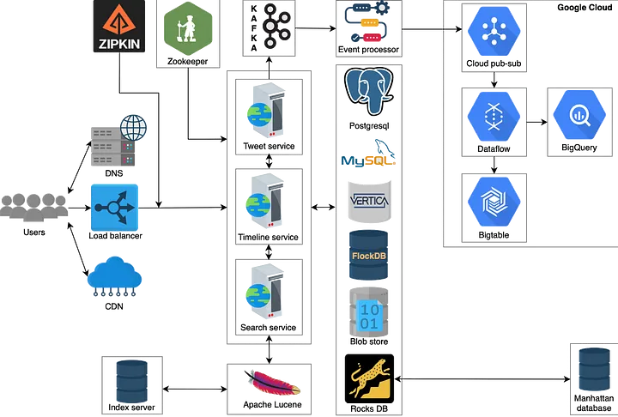

## User Interface (Web and Mobile Apps):

Description: The user interface is what users interact with to access Twitter's platform. This includes both the web application accessed via browsers and the mobile applications available on iOS and Android devices.

Functionality: The user interface allows users to perform actions such as tweeting, retweeting, liking, commenting, and messaging other users. It also provides features for profile customization, notifications, and discovery of content.

Importance: The user interface is the primary gateway for users to engage with Twitter's platform, making it essential for providing a seamless and intuitive experience across different devices and platforms.

## Backend Services (Microservices):

Description: Backend services consist of various microservices responsible for different functionalities of Twitter's platform. Each microservice is designed to handle a specific task or feature, such as user authentication, timeline generation, tweet processing, and analytics.

Functionality: Microservices communicate with each other via APIs to perform complex operations and maintain the overall functionality of the platform. They are independently deployable and scalable, allowing Twitter to update and scale different parts of its system without affecting the entire platform.

Importance: Backend services enable Twitter to modularize its architecture, making it easier to develop, deploy, and maintain different parts of the system independently. This approach improves agility, scalability, and fault isolation.

## Data Storage (Distributed Databases):

Description: Data storage refers to the databases and data stores used by Twitter to store various types of data, including user profiles, tweets, media files, and engagement metrics.

Functionality: Twitter employs distributed databases and storage solutions that can handle large volumes of data, support high throughput, and provide low-latency access to data. These databases are designed to be horizontally scalable, fault-tolerant, and consistent across multiple data centers.

Importance: Effective data storage is critical for Twitter to manage the vast amount of user-generated content and engagement data generated every second. Distributed databases ensure data reliability, availability, and scalability, enabling Twitter to deliver a seamless experience to its users.

## Messaging System (Pub/Sub Architecture):

Description: The messaging system facilitates communication and real-time updates across Twitter's distributed architecture. It follows a publish-subscribe (pub/sub) architecture, where publishers send messages to topics, and subscribers receive messages from topics they are interested in.

Functionality: The messaging system enables various components of Twitter's platform to communicate asynchronously and exchange real-time updates, notifications, and events. It helps ensure data consistency, scalability, and responsiveness across distributed services.

Importance: Pub/sub messaging is crucial for enabling real-time interactions, notifications, and event-driven workflows within Twitter's platform. It allows Twitter to scale its architecture horizontally and decouple components, improving flexibility and resilience.

## Content Delivery Network (CDN) for Media Distribution:

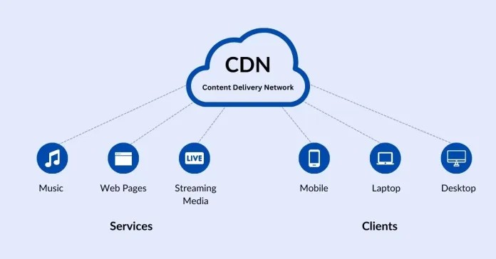

Description: The CDN is a network of servers distributed geographically to deliver static and dynamic content, such as images, videos, and other media files, to users with high performance and reliability.

Functionality: Twitter utilizes a CDN to cache and distribute media content closer to end-users, reducing latency and improving content delivery speed. The CDN also helps offload traffic from origin servers, optimize bandwidth usage, and mitigate distributed denial-of-service (DDoS) attacks.

Importance: Efficient media distribution is essential for enhancing user experience on Twitter's platform, especially for multimedia content like images and videos. By leveraging a CDN, Twitter ensures fast and reliable delivery of media content to users worldwide, regardless of their location.

# SCALABILITY MEASURES

## Horizontal Scaling:

Description: Horizontal scaling, also known as scaling out, involves adding more servers or instances to the existing infrastructure to distribute the load across multiple machines.

Functionality: When the demand on the system increases, instead of upgrading the existing servers, new servers are added to handle the increased load. This approach allows Twitter to accommodate a growing user base and handle spikes in traffic more effectively.

Implementation: Twitter's architecture is designed to support horizontal scaling by employing containerization (e.g., Docker) and orchestration tools (e.g., Kubernetes) to automate the deployment and management of multiple instances of microservices across a cluster of servers or cloud instances.

Benefits: Horizontal scaling improves system performance, scalability, and fault tolerance by distributing the workload across multiple servers, reducing the risk of bottlenecks and single points of failure.

## Load Balancing:

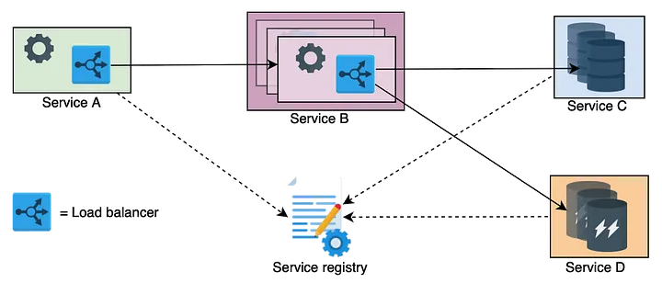

***Fig : How client-side load balancing works***

Description: Load balancing is the process of distributing incoming network traffic across multiple servers or resources to optimize resource utilization, maximize throughput, and minimize response time.

Functionality: Load balancers act as intermediaries between clients and servers, distributing incoming requests based on various algorithms (e.g., round-robin, least connections, weighted distribution) to ensure even distribution of workload.

Implementation: Twitter uses load balancers to distribute incoming requests across multiple instances of its backend services, ensuring that no single server becomes overwhelmed with requests. Load balancers also perform health checks on backend servers and route traffic away from unhealthy or overloaded servers.

Benefits: Load balancing improves system reliability, scalability, and availability by preventing any single server from becoming a bottleneck and ensuring that resources are utilized efficiently, even during peak traffic periods.

## Caching Strategies:

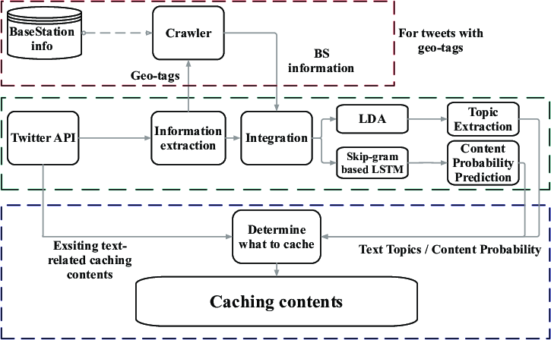

Description: Caching involves storing frequently accessed data in memory or a faster storage layer to reduce the latency and computational overhead of retrieving data from the original source.

Functionality: Twitter employs caching strategies to cache frequently accessed data such as user profiles, timelines, and static content (e.g., images, CSS files). By caching this data closer to the users, Twitter can serve requests more quickly and reduce the load on backend databases and services.

Implementation: Twitter utilizes distributed caching systems like Redis or Memcached to store cached data across multiple servers or nodes. Cache invalidation strategies are also implemented to ensure that cached data remains consistent with the underlying data source.

Benefits: Caching improves system performance, responsiveness, and scalability by reducing the time and resources required to fetch data from backend storage systems. It also helps mitigate the impact of sudden spikes in traffic by serving cached content to users, thereby reducing the load on backend services.

These scalability measures are essential components of Twitter's distributed system architecture, allowing the platform to handle increasing user traffic, maintain high availability, and deliver a seamless user experience even during peak usage periods.

# TEST SYSTEMS

Performance Testing: This involves evaluating the system's responsiveness, throughput, scalability, and stability under various load conditions. Performance testing tools simulate real-world user behavior to measure response times and identify performance bottlenecks. Twitter conducts performance testing to ensure that its platform can handle the expected volume of traffic without degradation in performance.

Stress Testing: Stress testing involves pushing the system beyond its normal operating limits to identify its breaking points and measure its resilience under extreme conditions. Twitter performs stress testing to assess how the system behaves under heavy loads, unexpected spikes in traffic, or resource constraints. This helps identify potential weaknesses and vulnerabilities in the system.

Fault Tolerance Testing: Fault tolerance testing evaluates the system's ability to recover from failures and disruptions gracefully. Twitter simulates various failure scenarios, such as server crashes, network outages, or database failures, to ensure that the system can maintain functionality and data integrity even in adverse conditions. This testing helps validate the effectiveness of redundancy, failover mechanisms, and disaster recovery procedures.

# DEPLOY SYSTEMS

Rollout Strategy: Twitter employs a rollout strategy to deploy system updates and changes gradually to minimize disruptions and mitigate risks. This may involve deploying updates to a small percentage of users initially (e.g., canary release), monitoring for any issues or anomalies, and gradually expanding the rollout to the entire user base. This approach helps identify and address issues early before they impact the entire platform.

Monitoring Tools: Twitter uses monitoring tools to track the health, performance, and availability of its distributed system in real-time. These tools collect and analyze performance metrics, logs, and system telemetry to identify anomalies, diagnose issues, and ensure that the system meets service level objectives (SLOs) and service level agreements (SLAs). Monitoring tools provide visibility into system behavior and enable proactive management and optimization of resources.

Incident Response Plan: Twitter has an incident response plan in place to effectively respond to and mitigate any disruptions, outages, or security incidents that may occur. The incident response plan outlines roles and responsibilities, escalation procedures, communication channels, and steps for incident resolution and post-incident analysis. This ensures a coordinated and timely response to incidents, minimizing impact on users and business operations.

# MONITOR SYSTEMS

Performance Metrics: Twitter monitors various performance metrics, such as response times, error rates, throughput, and resource utilization, to assess the health and performance of its distributed system. These metrics provide insights into system behavior, identify performance bottlenecks, and guide optimization efforts to improve system efficiency and reliability.

User Feedback: Twitter solicits and collects feedback from users through various channels, such as surveys, user forums, and support tickets. User feedback helps identify usability issues, feature requests, and areas for improvement in the platform. Twitter uses this feedback to prioritize product development efforts and enhance the user experience.

Security Audits: Twitter conducts regular security audits and assessments to identify and mitigate potential security vulnerabilities, threats, and risks in its distributed system. Security audits evaluate the effectiveness of security controls, compliance with security standards and regulations, and adherence to best practices. Twitter takes proactive measures to address security findings and continuously improve its security posture.

Feedback Loop: Twitter maintains a feedback loop with users, stakeholders, and internal teams to gather input, evaluate performance, and drive continuous improvement. Feedback from users, monitoring data, incident reports, and performance metrics inform decision-making and guide prioritization of enhancements and optimizations to the distributed system.

Iterative Development: Twitter adopts an iterative development approach to iteratively design, build, test, and deploy improvements and new features to its distributed system. Iterative development cycles enable rapid experimentation, feedback incorporation, and incremental enhancements, allowing Twitter to respond quickly to changing user needs, market trends, and technological advancements.

By following this structured approach, Twitter ensures the reliability, scalability, and performance of its distributed system architecture while continuously enhancing the user experience and addressing evolving challenges and opportunities.